# Resistor

A resistor is a passive electrical component that limits or regulates the flow of electrical current in a circuit.

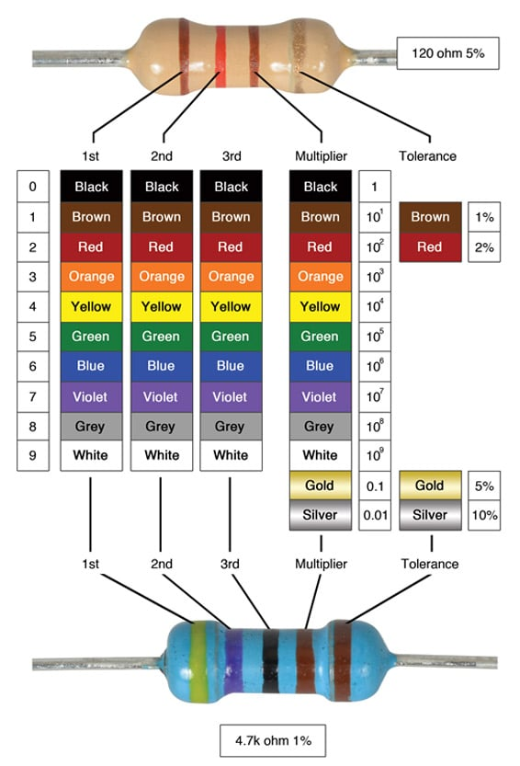**Working Principle:**  
It resists the flow of current, converting some electrical energy into heat. The amount of resistance is measured in ohms (Ω).

**Types**:  
- Fixed Resistor  
- Variable Resistor (Potentiometer, Rheostat)  
- Wire-wound Resistor  
- SMD Resistor  
- Thermistor, LDR (light-sensitive resistor)

**Applications**:  
- Voltage regulation  
- Current limiting  
- Pull-up/pull-down in digital circuits  
- Biasing transistors  
- Timing circuits

**Advantages**:  
- Simple and robust  
- Wide range of values available  
- Inexpensive

**Disadvantages**:  
- Power dissipation as heat  
- Not adjustable (for fixed types)